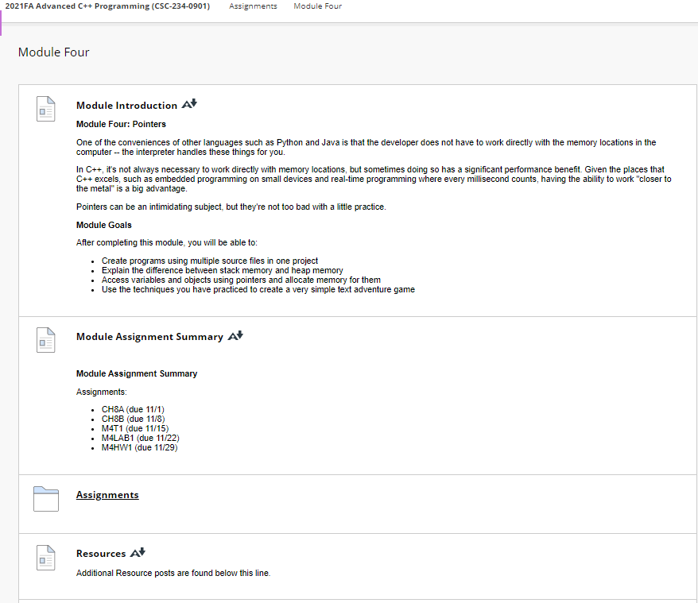

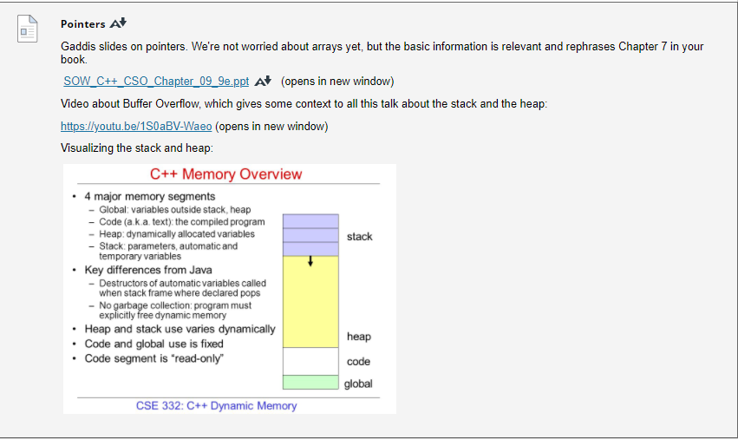

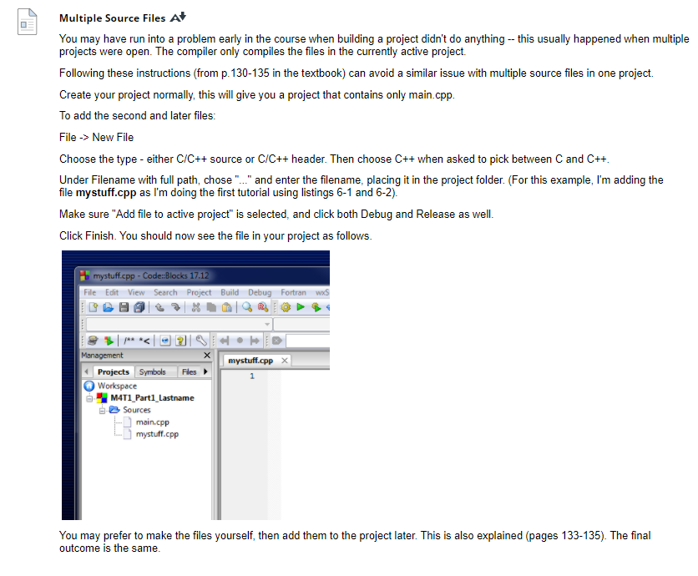

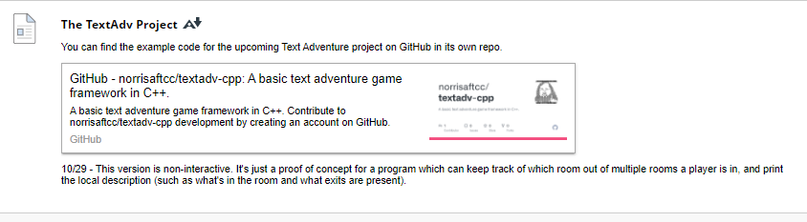

**Pointers**

[Pointers](https://faytechcc.blackboard.com/webapps/blackboard/content/listContent.jsp?course_id=_33824_1&content_id=_5842783_1)

Gaddis slides on pointers. We're not worried about arrays yet, but the basic information is relevant and rephrases Chapter 7 in your book.

[SOW_C++_CSO_Chapter_09_9e.ppt](https://faytechcc.blackboard.com/bbcswebdav/pid-5842788-dt-content-rid-54063197_1/xid-54063197_1) [SOW_C++_CSO_Chapter_09_9e.ppt - Alternative Formats](https://faytechcc.blackboard.com/webapps/blackboard/content/listContent.jsp?course_id=_33824_1&content_id=_5842783_1)  (opens in new window)

Video about Buffer Overflow, which gives some context to all this talk about the stack and the heap:

<https://youtu.be/1S0aBV-Waeo> (opens in new window)

Visualizing the stack and heap:

**Multiple Source Files**

[Multiple Source Files](https://faytechcc.blackboard.com/webapps/blackboard/content/listContent.jsp?course_id=_33824_1&content_id=_5842783_1)

You may have run into a problem early in the course when building a project didn't do anything -- this usually happened when multiple projects were open. The compiler only compiles the files in the currently active project.

Following these instructions (from p.130-135 in the textbook) can avoid a similar issue with multiple source files in one project.

Create your project normally, this will give you a project that contains only main.cpp.

To add the second and later files:

File -> New File

Choose the type - either C/C++ source or C/C++ header. Then choose C++ when asked to pick between C and C++.

Under Filename with full path, chose "..." and enter the filename, placing it in the project folder. (For this example, I'm adding the file **mystuff.cpp** as I'm doing the first tutorial using listings 6-1 and 6-2).

Make sure "Add file to active project" is selected, and click both Debug and Release as well.

Click Finish. You should now see the file in your project as follows.

You may prefer to make the files yourself, then add them to the project later. This is also explained (pages 133-135). The final outcome is the same.